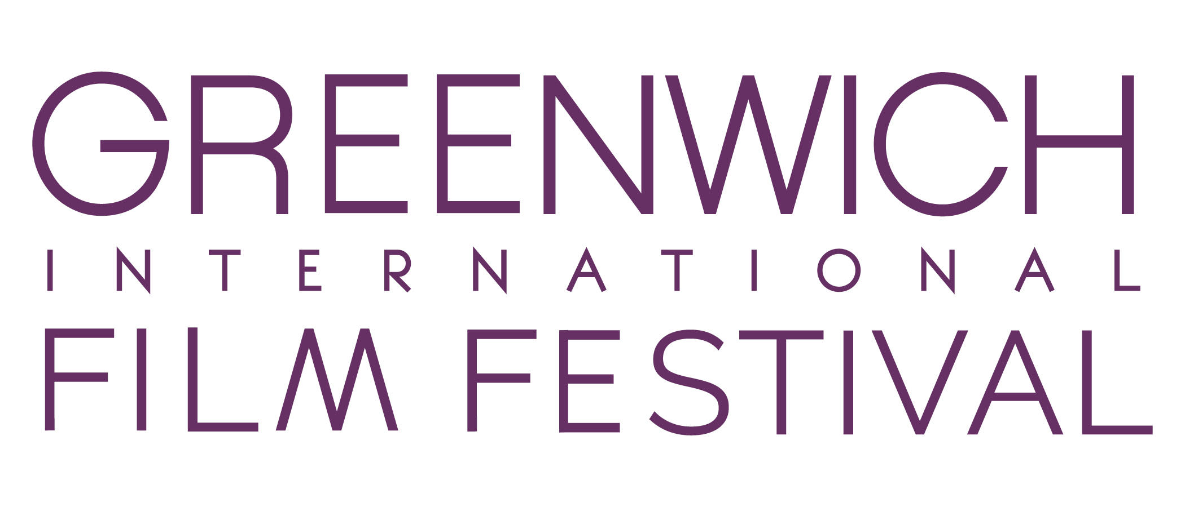

PROGRAMMING INTERN JOB DESCRIPTION

Greenwich International Film Festival is seeking a Programming Intern to work up to 10 hours a week beginning in January 2020, with a flexible end date of May or June 2020. Intern applicants should be dedicated, hard working individuals who want to work in a fast-paced environment. Good communication and writing skills are a must, as well as multitasking and the ability to work independently.

Internship Job Description:
- Help to launch the Call for Entries on Film Freeway
- Help with organization and selection of films including tracking, identifying and securing films.
- Articulate the programmatic mission and guiding principles to the international film community.
- Prepare, assign and write film synopses as well as describe the fundamental purpose and function of individual film programs and festivals.
- Prepare engaging film introductions.
- Help with all aspects of programming, both creative and administrative.
- Establish and maintain relationships with film community professionals.
- Help with creation and maintenance of the master film screening schedule and film database.
- Work with Director of Programming to help notify winners after Jury announcement for respective sections
- Assist in notifying all filmmakers of acceptance by the Festival
- Assist with additional administrative and marketing tasks related to programming
- Must be self-motivated, flexible, accountable, and routinely communicate with our staff
- Dress is casual when on-site

Internship Offers:
- An exciting, start-up environment to get hands-on work experience
- Sufficient opportunity to build your professional portfolio
- Tickets to the 2020 Festival

Please submit your resume to Neelab Hussaini at neelab@greenwichfilm.org

BACKGROUND INFORMATION:
Greenwich International Film Festival (GIFF) is a 501©3 non-profit organization that hosts a world-class film festival each June, as well as events throughout the year. The festival’s goal is to bridge the worlds of film, finance and philanthropy. As part of its mission, GIFF harnesses the power of film to serve the greater good by highlighting social impact issues and supporting important charitable causes through a portion of festival proceeds. Learn more at www.greenwichfilm.org.

